Q1. Write difference between SAAS,PAAS,IAAS.

Ans:

* SAAS:

1. SAAS stands for software as a service
2. Client/User is the end user of SAAS
3. SAAS works on top of PAAS
4. Hence, SAAS requires both PAAS and IAAS
5. SAAS provides user the application developed by deployed by the developers.
6. Ex: Gmail , Youtube , Microsoft 365, Google Maps, etc.

* PAAS

1. PAAS stands for Platform as a Service
2. PAAS works on the top of IAAS
3. Hence, PAAS requires good infrastructure to function properly.
4. It provides the user platform to develop, manage and maintain various applications.
5. It provides development environment as well
6. Ex: AWS, IBM Cloud, Google Cloud, etc.

* IAAS

1. IAAS stands for Infrastructure as a Service
2. IAAS consists of providing hardware virtually as per the need of user.
3. IAAS consists of CPU, GPU, RAM, i/o Devices, SSD, etc.
4. Ex: Google Cloud, Microsoft Onedrive, Azure, etc.

Q2. Explain with diagram architecture of cloud(public) any provider.

Ans.

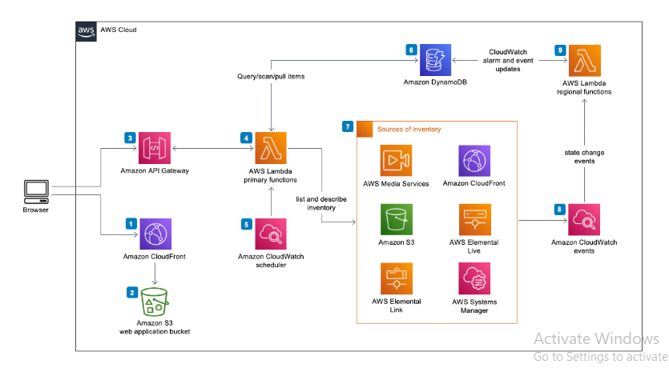

Q3. Study about five services from AWS ,GCP,Azure and Heroku.

Ans:

* AWS:

1. EC2 : Elastic Cloud Computing:

Provides control of resources and maintain the application environment

1. RDS: Relational Database Services
2. S3: Simple Storage Service
3. CLOUDFRONT
4. VPC : Virtual Private Cloud

* GCP

1. Google VPC
2. Cloud SQL
3. Google App Engine
4. Kubernetes Engine
5. Cloud IAM

* Azure

1. Resource Health Alerts
2. Azure Cosmos DB Free Tier
3. Azure Advisor Recommendations
4. Azure Arc

Q4. Write the difference between database services of AWS , GCP Azure,Heroku.

Ans:

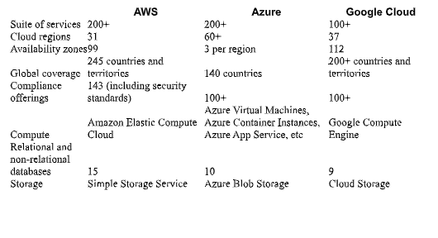

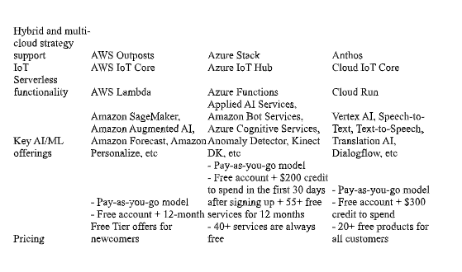

Advanced Assignments(optional)

Q1. Find services for big data on AWS , GCP Azure,Heroku.

Q2. Compare services for big data on AWS , GCP Azure,Heroku.

Q3. Find services for Machine learning on AWS , GCP Azure,Heroku.

Q4. Compare services for Machine learning on AWS , GCP Azure,Heroku.